**Metadata document for the 1992-2019 flood extent from passive microwave brightness temperatures**

Data prepared by Paolo Colosio and Marco Tedesco

*Correspondence to:* [p.colosio002@unibs.it](mailto:p.colosio002@unibs.it); [mtedesco@ldeo.columbia.edu](mailto:mtedesco@ldeo.columbia.edu)

**Data:**

Two datasets called (1) *bangladesh_magnitude_YYYY* and (2) *bangladesh_binary_YYYY* in *.mat* format.

1. Each file contains (i) two 3D arrays (407 pixels, 293 pixels, DAY), “flood magnitude” (*MA*, defined later in “Methods”) and 4 days moving average flood magnitude (*MA_avg*) for the year, (ii) two (407, 293) maps for longitude (*LON*) and latitude (*LAT*) coordinates and (iii) two (407, 293) maps containing mean (*mean_sha*) and standard deviation (*std_sha*) of the 1992-2019 “C/M ratio” (defined in “Methods”) timeseries for every pixel.
2. Each file contains 8 (one for each selected threshold, 4 daily and 4 smoothed by a 4-days rolling average, described in “Methods”) binary 3D arrays (407 pixels, 293 pixels, DAY) denoted as *floodXXX* and *floodXXX_avg*. The variable assumes the value 1 if flood is detected and 0 if not. The variable names *flood1_5*, *flood2* and *flood4* refer to the fixed threshold evaluated as 1.5, 2 and 4 standard deviations above the mean of the “C/M ratio”. The variable name *flood95* refers to the dynamic (spatially) threshold computed as the 95th percentile of the “C/M ratio” timeseries. Coordinates matrices are provided as well (*LON* and *LAT*).

The datasets produced are obtained from enhanced resolution gridded enhanced resolution data. Specifically, 37 GHz Horizontal polarization brightness temperatures have been adopted.

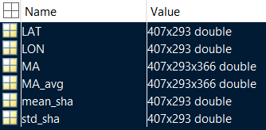

**a)**

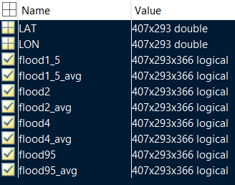

**b)**

**Figure 1 Variable of the a) *banglades_magnitude_YYYY* and b) *bangladesh_binary_YYYY* files.**

**Method:**

Passive microwave (PMW) sensors detect the energy naturally emitted by the earth surface. The peculiarities of PMW spaceborne data are related to their long (1979-now) and continuous (at least every other day) temporal coverage, being able to collect data in all-weather conditions, and the large spatial coverage (global). On the other side, the spatial resolution is relatively coarse. To produce this dataset, data from the Special Sensor Microwave /Imager (SSM/I) and the Special Sensor Microwave Imager/Sounder (SSMI/S) at Ka- band (37 GHz), horizontal polarization (H-pol.) collected during the ascending (A) pass of the satellite between 1992 and 2019 have been used. The satellite images are available through the NASA MeASUREs project (information about the data are available here <https://nsidc.org/data/nsidc-0630/versions/1>) at the spatial resolution of 25km and 3.125km (produced using a new gridding algorithm based on the antenna gain function called rSIR technique, Brodzik et al., 2018). Passive microwave data have been used to monitor and map large flood events due to their sensitivity to the presence of water over land (the brightness temperature signal decreases as the the amount of water increases) and several algorithms have been proposed. A variation of the algorithm proposed by De Groeve and Riva (2009) has been applied. The basic assumption is that close pixels have similar land surface properties (affecting the brightness temperature). The measured (M) brightness temperature value of a pixel is considered as the combination of water and land brightness temperature contributions (proportionally to the fractional area.



where

*w*: fractional area of water;

$ε_{water}$: water emissivity;

$ε_{land}$: land emissivity;

Tmeasurement: physical temperature at the measured pixel.

The brightness temperature values of M signal (wet or dry) are divided by the calibration (C, dry) observations, referred to as M/C ratio or signal s.

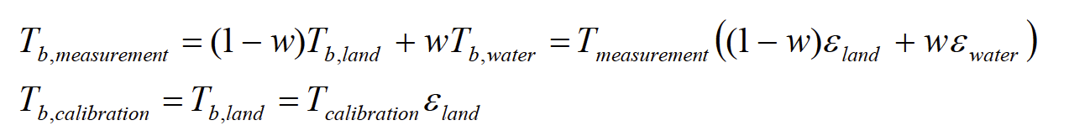

For nearby pixels we assume



then

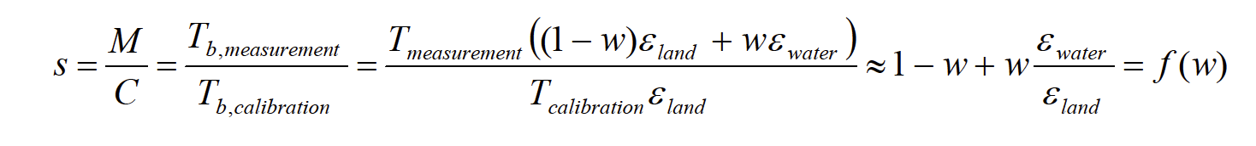

As an example, Figure 3 shows an example of time series of M, C and the flood signal s (Ratio MC) over the Indus River in Pakistan from De Groeve and Riva (2009) (actually the plot shows the C/M ratio). The three peaks correspond to flood disasters in 2003, 2005 and 2006.

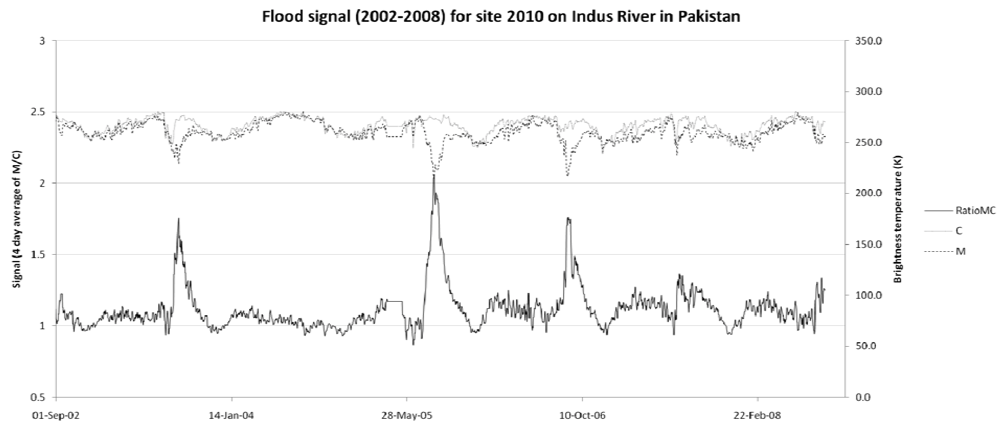

**Figure 5 Example of time series of M, C and the flood signal s (RatioMC) over the Indus River in Pakistan from De Groeve and Riva (2009). The three peaks correspond to flood disasters in 2003, 2005 and 2006.**

As automatic selection of the calibration pixel (C value) De Groeve and Riva (2009) suggested to select the 95th percentile in a moving window of 7 x 7 pixels (30,625 km2). This choice reduces the probability of errors by picking a possible extremely high value due to sensor malfunction. Here a larger (14 x 14 pixels) has been selected, according to a preliminary analysis of the timeseries of calibration values.

When a pixel is flooded, the M value decreases (while C value keep does not) leading to an increase of the C/M ratio.

The flood magnitude (MA) is defined as the number of standard deviations from the mean of the signal every day:

$MA(t)=\frac{C/M(t)-mean(C/M)}{std(C/M)}$

According to De Groeve and Riva (2009), regular flood events show anomalies of 2 and large flood events of 4. Alternatively, floods are identified as anomalies over the 95th percentile of the C/M timeseries.

The binary maps in files *bangladesh_binary_YYYY* contain outputs obtained applying thresholds of 1.5, 2 and 4 to the flood magnitude dataset (*bangladesh_magnitude_YYYY*, variable *MA*) and the 95th percentile threshold to the C/M signal (not reported in the dataset but simply obtained by reverse formulation of *MA* through mean and standard deviation of C/M). The thresholding algorithm has been applied both to the daily images and to a 4-day rolling average smoothed C/M signal.

**Reference:**

De Groeve, T., & Riva, P. (2009, May). Global real-time detection of major floods using passive microwave remote sensing. In Proceedings of the 33rd international symposium on remote sensing of environment, Stresa, Italy (pp. 4-8).

Brodzik, M. J., Long, D. G., Hardman, M. A., Paget, A., & Armstrong, R. L.: MEaSUREs Calibrated Enhanced-Resolution Passive Microwave Daily EASE-Grid 2.0 Brightness Temperature ESDR, Version 1; National Snow and Ice Data Center: Boulder, CO, USA, Digital Media, doi: <https://doi.org/10.5067/MEASURES/CRYOSPHERE/NSIDC-0630.001>, 2016. Updated 2018.